**Human Act Recognition**

A MINI-PROJECT REPORT

*By*

**Mohit Kunder (8344)**

**Benita Rego (8362)**

**Nolita Rego (8363)**

*Under the guidance of*

**Prof. Dipali Koshti**



DEPARTMENT OF COMPUTER ENGINEERING

FR. CONCEICAO RODRIGUES COLLEGE OF ENGINEERING

FR. AGNEL ASHRAM, BANDRA (W),

MUMBAI - 400 050.

**UNIVERSITY OF MUMBAI**

**(2019 – 2020)**

**FR. CONCEICAO RODRIGUES COLLEGE OF ENGINEERING**

**FR. AGNEL ASHRAM, BANDRA (W),**

**MUMBAI - 400 050**.



**CERTIFICATE**

This is to certify that the following students working on the project “Human Act Recognition**”** have satisfactorily completed the requirements of the project in fulfillment of the course T.E in Computer Engineering of the University of Mumbai during academic year 2019-2020 under the guidance of “**Prof. Dipali Koshti**”.

Submitted By: Mohit Kunder (8344**)**

Benita Rego (8362**)**

Nolita Rego (8363**)**

|  |  |
| --- | --- |
| **Prof.**  **Guide** | **Dr. B.S.Daga**  **Head of the Department** |

**________**

**Principal**

|  |
| --- |
|  |
|  |

**CERTIFICATE**

This is to certify that the project synopsis entitled “Human Act Recognition**”** submitted by the following students is found to be satisfactory and the report has been approved as it satisfies the academic requirements in respect of mini-project work prescribed for the course.

Name: Mohit Kunder

Benita Rego

Nolita Rego

|  |  |
| --- | --- |
| **Internal Examiner**  (Signature)  Name:  Date: | **External Examiner**  (Signature)  Name:  Date: |

**Seal of the Institute**

**DECLARATION OF THE STUDENT**

We declare that this written submission represents our ideas in our own words and where others' ideas or words have been included, we have adequately cited and referenced the original sources.

We also declare that we have adhered to all principles of academic honesty and integrity and have not misrepresented or fabricated or falsified any idea / data / fact / source in my submission.

We understand that any violation of the above will be cause for disciplinary action by the Institute and can also evoke penal action from the sources which have thus not been properly cited or from whom proper permission has not been taken when needed.

Signature of the student **Date:**

**(Mohit Kunder**)

**(8344**)

Signature of the student **Date:**

**(Benita Rego**)

**(8362**)

Signature of the student **Date:**

**(Nolita Rego**)

**(8363**)

**ACKNOWLEDGMENT**

*I have taken efforts in this project. However, it would not have been possible without the kind support and help of many individuals. I would like to extend my sincere thanks to all of them.*

*I am highly indebted to Prof. Dipali Koshti for their guidance and constant supervision as well as for providing necessary information regarding the project & also for their support in completing the project.*

*My thanks and appreciations also go to my colleagues in developing the project and people who have willingly helped me out with their abilities.*

**ABSTRACT**

**Introduction**

Human machine interaction becomes one of the most research topics in multimedia processing, traditional techniques for communication are developed in order to tackle technology advances and allow disable person to communicate easily with the machine, and to understand their activity using computer computing. In this paper we are focused on human act detection from video scene and it is worth noticed that many information are hidden sudden motion and walking speed, many research works tried to model and then recognize human behavior through motion analysis. In our work we will explain the human action recognition using openCV.

**Problem Statement**

The safety of senior citizens and children living alone at their residence have been a big concern for working individuals taking care of them. There is a need for a solution which can ensure 100% safety. So, the solution should be such that the working individual can monitor them from their workplace itself. The following points should be considered:

* Any suspicious actions should be detected
* Alert the individual wherever he/she is
* Monitoring through surveillance

**Table of Contents**

Chapter 1: Introduction**………………………………………………………………………8**

Chapter 2: Literature Review**………………………………………………………………...8**

Chapter 3: Proposed System**………………………………………………………………….9**

3.1: Problem statement Analysis**………………………………………………………9**

3.2: Design and Methodology of proposed system**…………………………………...10**

3.3: Algorithms**………………………………………………………………………..11**

Chapter 4: Hardware software requirements and Implementation**……………………….…..11**

4.1: Results

4.2: Conclusion

References(IEEE Format)**…………………………………………..……………………….12**

**1. Introduction**

Human act recognition is a system designed for the senior citizens or people living alone in their apartment who need assistance.

The analysis of human behavior is an important area of research in computer vision dedicated to the detection, monitoring and understanding of the physical behavior of people. The applications that consider behavior analysis are embedded in many systems such as smart video surveillance [for automatic control inputs and outputs of certain objects, the identification and recognition of persons, detection of unusual behavior, virtual reality systems, human-machine interaction (HMI), augmented reality systems as virtual systems taking into account the behavior of people are the most used.

The purpose of this document is to describe the external requirements for Human Act Recognition system for different scenarios like security, crime scene detection at tolls, isolated areas, residential societies, etc. But for this, the system is made for residents where senior citizens or people suffering from some illness living alone who need constant surveillance. It also describes the interfaces for the system.

Scope of this project extends to analyzing the human action and behavior, also increasing the security of individuals where this system will alert the relatives of the individual under surveillance if the person is in distress. This project and the implementation with openCV model can be used for many scenarios for the same. It gives a proper explanation and implementation of various new technologies like the usage of openCV, integration using flask, different image processing techniques and other machine learning libraries.

**2. Review of Literature**

For many years human action recognition has been studied well. Most of the action recognition methods require to manually annotate the relevant portion of the action of interest in the video. In recent years it has been studied that the relevant portion of action of interest can be found out automatically and recognize the action. We can review the action recognition methods.

The system makes use of openCV. OpenCV (Open Source Computer Vision) is a library of programming functions mainly aimed at real-time computer vision. The system first marks the 17 skeleton points on the body and detects the body movements. It recognizes those movements that are suspicious and alerts the user operating the system via a text or a call. The data has a backup too that is, it records the data and stores it in the database for later use. This system introduces a method that easily detects poses and actions and alerts the user regarding any behavior.

**3. Report on the proposed system**

The main users of this system will be the organization’s admin.

The authorities can enter the web app by creating an account entering keydetails. An email verification based authentication is implemented for security purposes.

Once the user’s profile is created, they can connect their camera’s identification number. Then, the user can have access to those areas under camera surveillance.

**User registration:** System will allow the user to add themselves on the system. The system requires that the user to enter details like name of the individual living in the house, age, address, user of the system, relation with the individual, contact of the user, email and password. Authentication by: Email.

**View Surveillance:** The user of the system can view the surveillance once the profile is created.

**Sign In:** The user needs to sign in to the system with the email and password he/she have provided with. The system needs to check for that email and password and then only allow him/her to access the system.

**Database:**

**User:** Each user shall have the following Mandatory information: name of the individual living in the house, age, address, user of the system, relation with the individual, contact of the user, email and password.

**3.1. Problem Statement Analysis**

* The system activates a camera to check on all the activities which then detects if the system detects a suspicious behavior.
* Any suspicious actions should be detected:

The system provides an easy method to detect particular actions that the system is built to detect that is, movements that are found suspicious and these actions are detected by the points marked on human body by the software.

Alert the individual wherever he/she is:

The actions of suspicious behavior caught on the camera is detected and then alerted to the user via a text on Whatsapp, thus keeping the user aware of the activities happening.

* Monitoring through surveillance:

A camera is used to monitor the individual in real-time which is connected to the user’s system for the purpose of surveillance.

**3.2. Design and Methodology of proposed system**

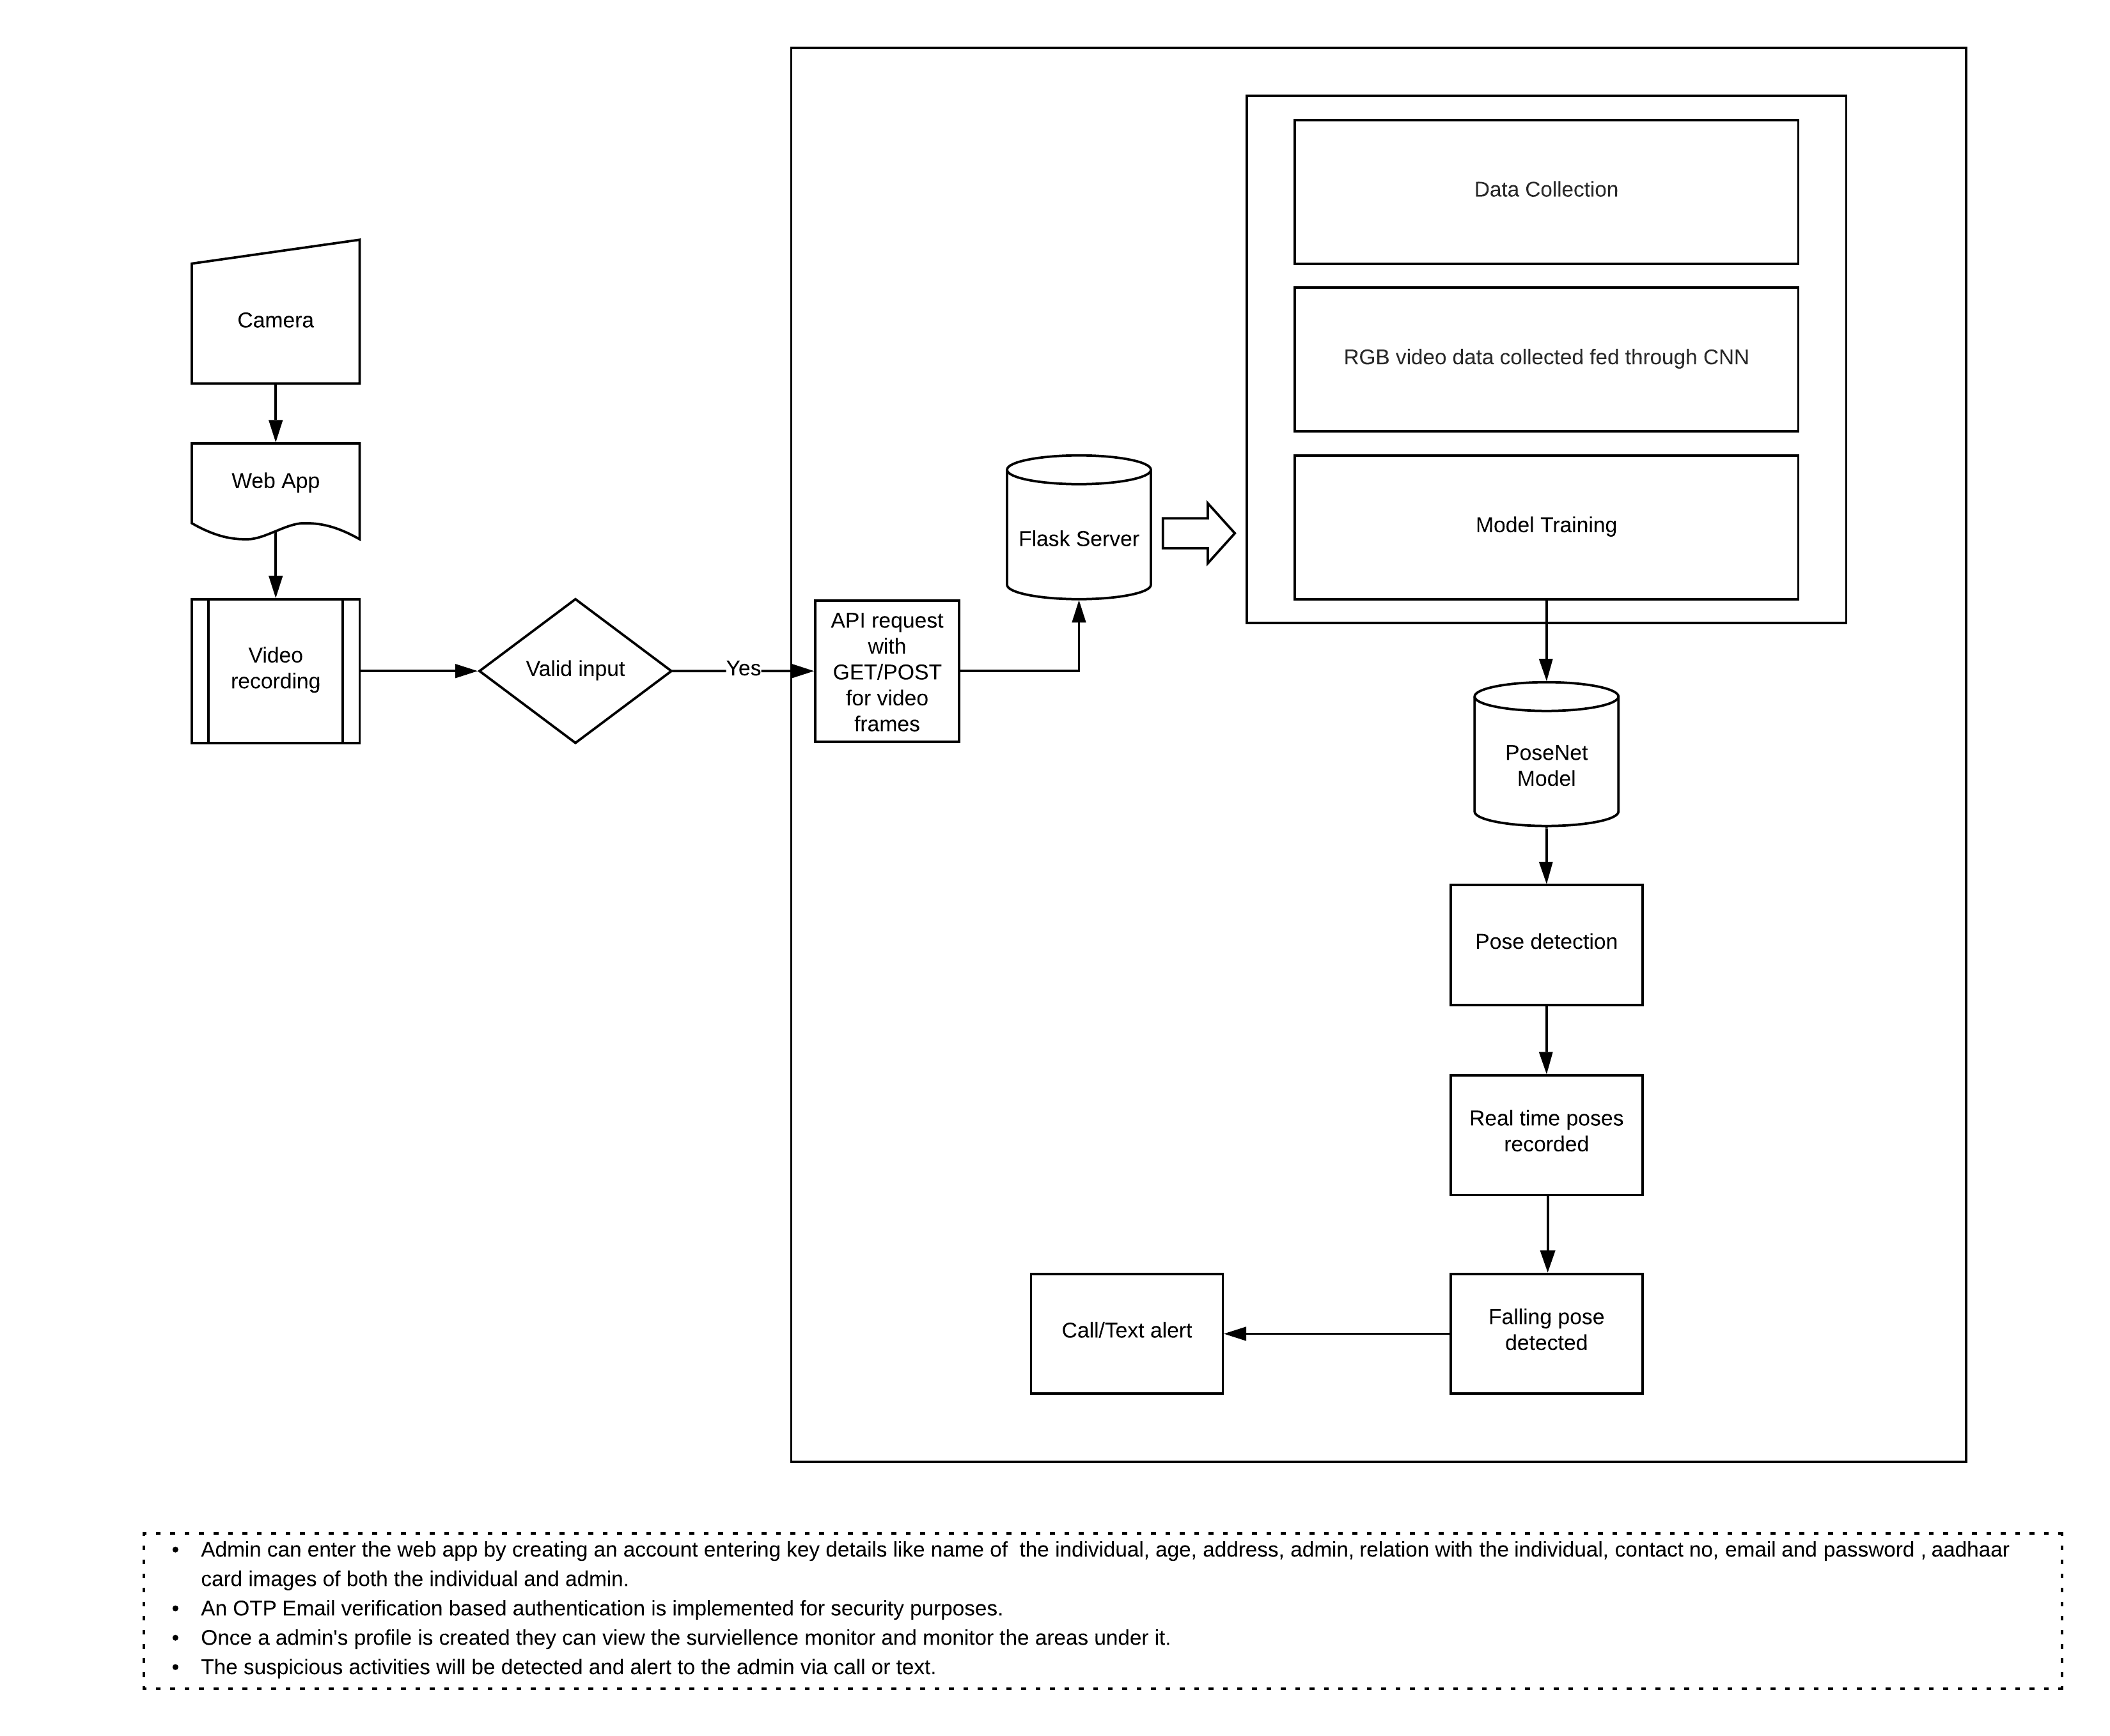

Figure 3.2.1. Block Diagram of Proposed system

**3.3 Algorithms**

1. Given a video as an input.

2. Input given is converted into gray color.

3. The gray color of the individual is different from the background. Therefore, the background is erased.

4. After removal of background, a contour is drawn around the moving individual (Contour is a line joining the boundary points of an image used for shape analysis.)

5. If contour is less than a specific width,

then add 1 to the count variable.

6. If the count variable increases more than 10,

then fall is detected.

7. The fall detected is saved in the database as backup.

8. After detection, a text or call sent to the individual immediately as an alert message.

**4. Hardware software requirements and Implementation**

**Hardware requirement:** A camera

**Software requirements:** Python libraries, openCV, poseNet, Firebase

UI: HTML, CSS, Javascript

**4.1 Results**

We have developed a Machine Learning model using poseNet, openCV and a website to integrate the given model. Also, we have integrated the model using Flask and deployed the website on some web hosting service. The system hence, is made useful for working individuals to look after the senior citizens and children when they are away. The system successfully delivers the need of the user i.e. provides camera surveillance, has a backup data recorded and alerts the user if any suspicious behavior is noted.

**4.2 Conclusion**

The individuals in the camera footage is recorded and stored in a database. The areas will be constantly under surveillance. The individual’s actions is detected and recognized which will be analyzed. If any suspicious behavior is detected then it is informed to the user of the system (relative of the individual) through social media platform i.e. text or call. All the camera recordings is saved in the database. This system is to find out the individual’s behavior at the present scene, so as to increase the security of the individual living alone at his residence.

**5. References**

|  |  |
| --- | --- |
| Alex Kendall Matthew Grimes University of Cambridge agk34, mkg30, rc10001 @cam.ac.uk Roberto Cipolla “PoseNet: A Convolutional Network for Real-Time 6-DOF Camera Relocalization”:  Albert Ali Salah, Theo Gevers, Nicu Sebe and Alessandro Vinciarelli “Challenges of Human Behavior Understanding”: University of Glasgow  *https://ml5js.org/reference/api-PoseNet/*  *https://www.ijert.org/research/human-action-recognition-a-literature-review-IJERTV4IS090711*  *J34_Vrigkas_Nikou_Kakadiaris_Frontiers_RAI_2015* |  |